LAB 7: Data-Driven Modeling of DC Servo Motor

Course Number | MENG 3020
Course Title | System Modeling & Simulation
Semester/Year | Fall 2025

Lab/Tutorial Report No. | Lab 7
Report Title | Data-Driven Modeling of DC Servo Motor
Section No. | 0NA
Group No. | N/A
Submission Date | November 22nd, 2025
Due Date | November 23rd, 2025

Student Name | Signature* | Total Mark
Michaël McCorkell |  | / 50

* By signing above, you attest that you have contributed to this submission and confirm that all work you have contributed to this submission is your work. Any suspicion of copying or plagiarism in this work will result in an investigation of Academic Misconduct and may result in a ZERO on the work or possibly more severe penalties.
https://academic-regulations.humber.ca/2021-2022/17.0-ACADEMIC-MISCONDUCT

LAB 7 Grading Sheet

Student First Name:  Michael | Student Last Name:  McCorkell
Part A: System Identification from Noise-free Data |  | /15
Part B: System Identification from Noisy Data |  | /20
Post Lab Assignment |  | /10
General Formatting: Clarity, Writing style, Grammar, Spelling, Layout of the report |  | /5
Total Mark |  | /50

LAB 7: Data-Driven Modeling of DC Servo Motor

OBJECTIVES
- To explore the system identification approach to model linear and nonlinear systems
- To understand the nonlinear characteristics of dynamic systems such as dead-zone, saturation and gear backlash and ensure that the system operates in the linear range.
- To apply system identification workflow to understand the importance of data collection, model selection, model fitting and model validation.

INTRODUCTION
System identification approach consists of associating a mathematical model with a measured experimental behavior. Here the system is considered as a black box with an input variable and an output variable. The idea is to input a known input variable to the system and to raise the output variable. We then need to find a mathematical model for the system transfer function that will yield the same relationship between input and output. This method provides only a model of the global behavior of the system, without delving into the separate influences of the various performance parameters.
The method provides a model experimentally validated without having to write the equations that govern the behavior of the system. The model should be treated with caution in case non-linear phenomenon enter the actual system’s behavior. In practice we always perform several tests corresponding to different constraints
Aside from simple cases, identification of the transfer function requires significant computational resources. The software tool will enable us to automate this task by suggesting mathematical models for identification processes that could be complex.
MATLAB provides a toolbox called “System Identification” which allows this process to be carried out. We can use time-domain and frequency-domain input-output data to identify continuous-time and discrete-time transfer functions, process models, and state-space models. The toolbox also provides algorithms for embedded online parameter estimation. System Identification Toolbox lets us create models from measured input-output data. We can (a) Analyze and process data, (b) Determine suitable model structure and order, and estimate model parameters, (c) Validate the model accuracy.
Data Driven Modeling of DC Motor
- Open the Simulink model DC_Motor_System.slx which is compatible with your MATLAB version.
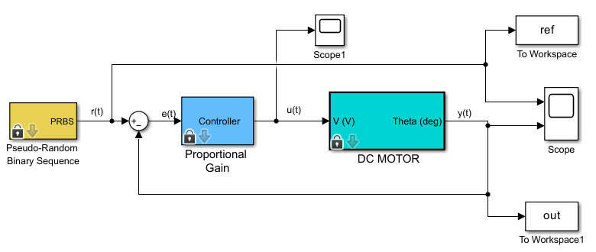
The model represents closed-loop position control of a DC motor under proportional controller.
The reference signal is a Pseudo-Random Binary Sequence (PRBS) signal.
The output signal is the angular position of the motor shaft in degrees.
- Open the Block Parameters by double-clicking on the appropriate block. Enter the following values for each block:
a) Pseudo-Random Binary Sequence:
Number of Sample Points = 2000, Switch Constant = 80, Amplitude = 40 degrees
b) Proportional Gain:
Proportional Gain = 1
c) DC Motor:
Armature Inductance = 0.15×10⁻³ H, Armature Resistance = 3 Ω,
Motor Inertia = 2.47×10⁻⁷ oz.In.sec², Motor Viscus Friction = 1.2319×10⁻⁷ N.m.sec,

Part A: System Identification from Noise-free Data
- In DC Motor block set Additive Noise = 0.
- Run the simulation for 10 seconds. Open both Scope blocks. You will see the input-output data and the control signal. Ensure that the control signal is not saturated. Decrease the amplitude of input signal if required. Provide the graph below:
Noise-free Input-Output Data
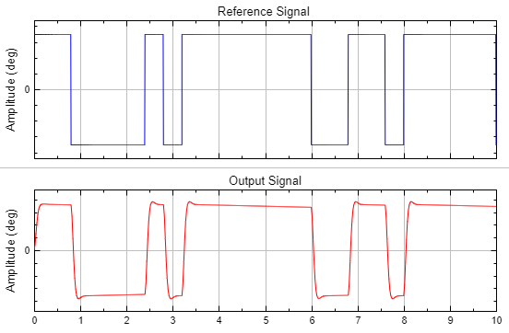

- The input and output data will be saved in variables ref and out that are available in MATLAB Workspace.
- Run the following code in MATLAB to create the identification and validation datasets in the Workspace.
% identification dataset
outi = out(1:1000);
refi = ref(1:1000);

% Validation dataset
outv = out(1001:end);
refv = ref(1001:end);

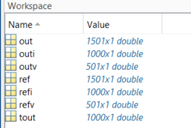
- In MATLAB Window, APPS tab, click on the System Identification app to run the “System Identification” toolbox.
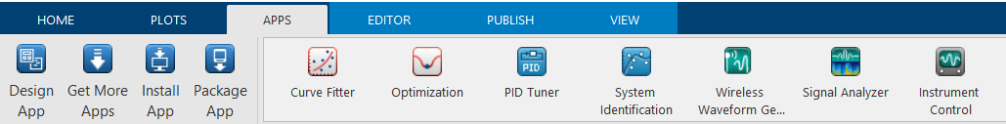

The System Identification User Interface window will be opened as below. It is possible to import data in Time-domain, Frequency-domain and Data object. In our example the data from experiment is a Time-domain data.
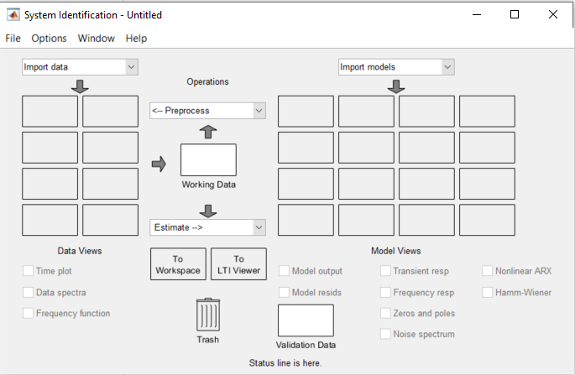
Validation Dataset
Choice of the Model
Display Data from Identification
Imported Datasets
Data Import

- Select Import data > Time domain data. This command opens the Import Data window to define the data necessary for identification and validation.
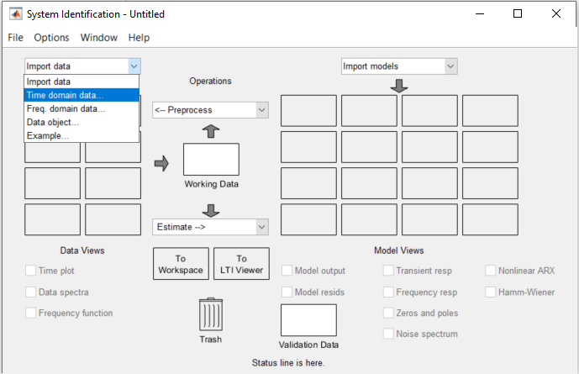

Complete the Import Data window as shown below to create the identification dataset and validation dataset. Each time clicking Import the data will appear in the System Identification window.

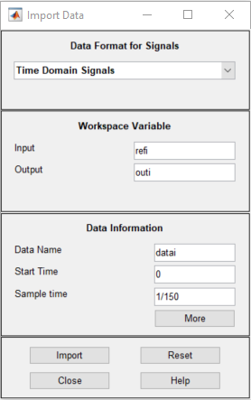
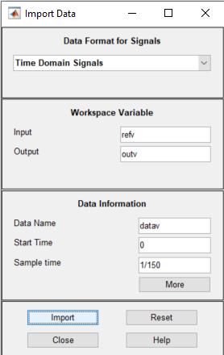

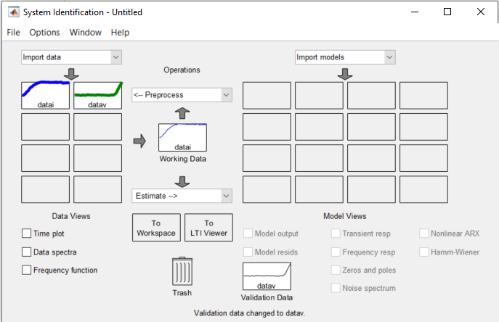

- Drag and drop the datai in the Working Data box and the datav in the Validation Data box.
- We can plot the identification and validation datasets by selecting the desired dataset and deselecting the others and then check the box Time plot. Select datai and deselect datav. Check the box Time plot. The identification dataset will be shown. Select datav and deselect datai. Check the box Time plot. The validation dataset will be shown. Provide the graphs below:
Noise-free Identification Dataset Noise-free Validation Dataset
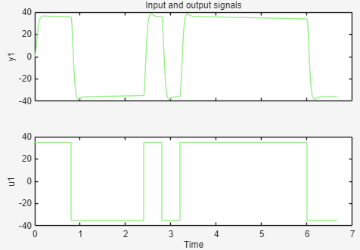 | 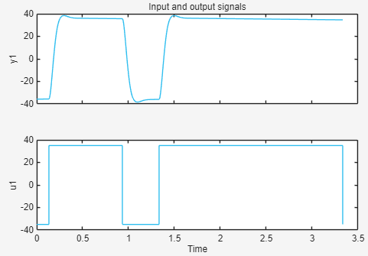

- Select the desired model type as Transfer Function Models.

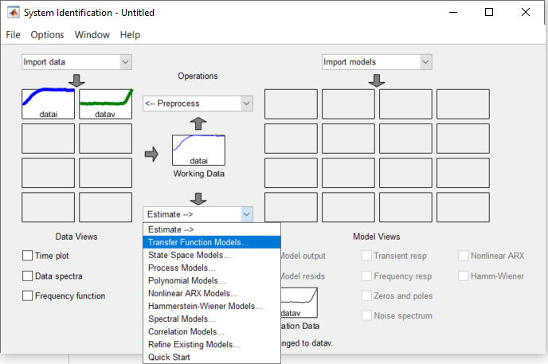

- The window that opens allows us to choose the desired type of transfer function. Here we use a second order transfer function with 2 poles and no zero and no delay. Set the model structure as below and click Estimate.
Model name = model1, Number of poles = 2, Number of zeros = 0,
Check the Continuous-time model.
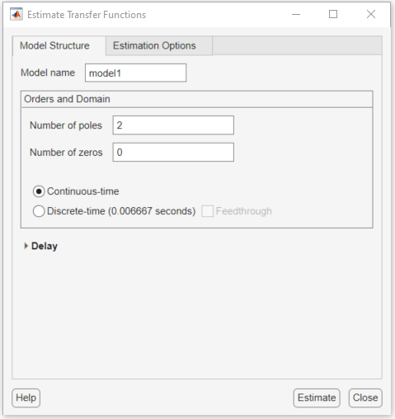

- The system Identification Progress window will appear, which shows the selected algorithm and the status of the estimation. Provide the percent of fit to estimation data and the FPE values below:
Fit to estimated data = 98.16 %
Final Prediction Error (FPE) = 0.39239

- The identified model model1 will appear in the Identification Results chart. The result of the identification is available by right clicking the mouse on the model1 box representing the identification results.
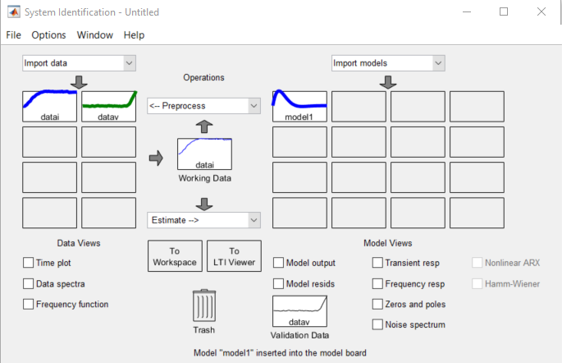
Results from identification

- Right-click on the model1 box and find the estimated transfer function model of the DC motor system. Provide the model and the validation criteria below:

Estimated Transfer Function Model =
From input "u1" to output "y1":
$$\frac{847.9}{s^{2}\text{+}41.45s\text{+}837.4}$$
Fit to estimated data = 98.16 %

FPE = 0.3924

MSE = 0.3885

- Select model1 and check the Model output box to view the overlap of the validation data and the model resulting from the identification. Provide the graph with the Best fit results below. Check the Zero and poles box to view the pole-zero map. Provide the graph below.
Cross-Validation Results for Noise-free Dataset Pole-Zero Plot for Noise-free Dataset
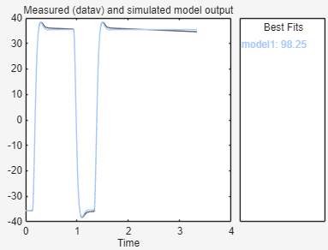 | 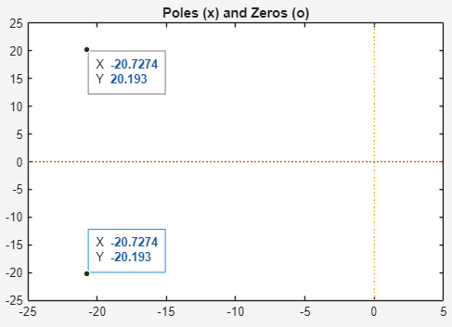

- Enter the pole and zero values below:
Poles = -20.7274 ± 20.193
Zeros = No Zero

- Drag the model1 box to To LTI Viewer box to plot the unit-step response of the system. Provide the step response graph below:
Unit-Step Response (Noise-free Data) Step Response Specifications
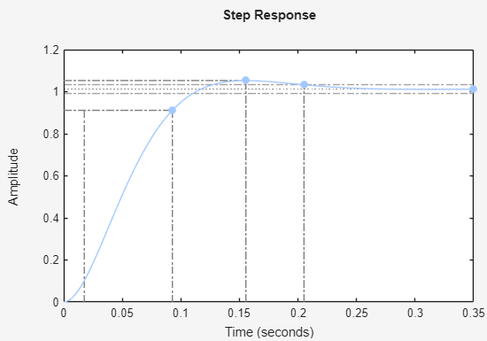 | Rise time = 0.0752 sec  Peak time = 0.156 sec  Overshoot = 3.98 %  Settling time = 0.205 sec  Steady-state value = 1.01  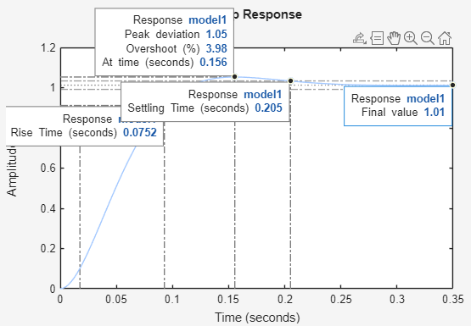

Part B: System Identification from Noisy Data
- In DC Motor block set Additive Noise = 1.
- Change the input and output data name to refn and outn to distinguish between the noisy and noise-free datasets in Part A and Part B.
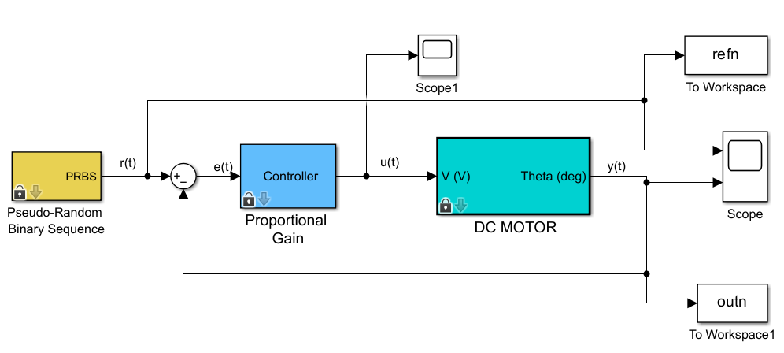
- Run the simulation for 10 seconds. Open both Scope blocks. You will see the input-output data and the control signal. You will clearly see the noise effect on the output data and the control signal. Ensure that the control signal is not saturated. Decrease the amplitude of input signal if required. Provide the graph below:
Noisy Input-Output Data
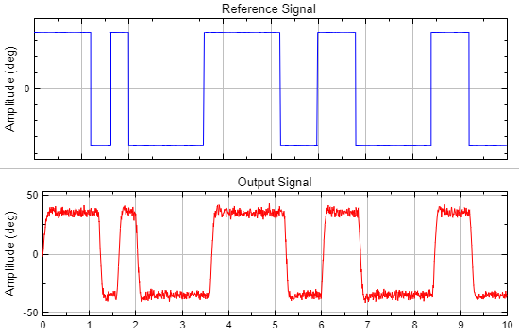

- Run the following code in MATLAB to create the new identification and validation datasets in the Workspace.
% identification dataset
outni = outn(1:1000);
refni = refn(1:1000);

% Validation dataset
outnv = outn(1001:end);
refnv = refn(1001:end);

- Repeat the Steps 7 to Step 10 to plot the identification and the validation datasets for noisy data. Provide the graphs below:
Noisy Identification Dataset Noisy Validation Dataset
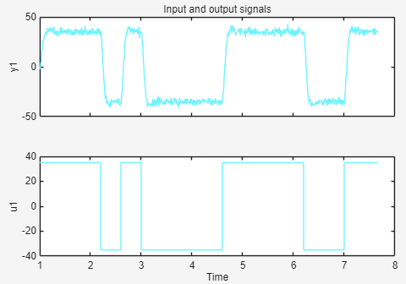 | 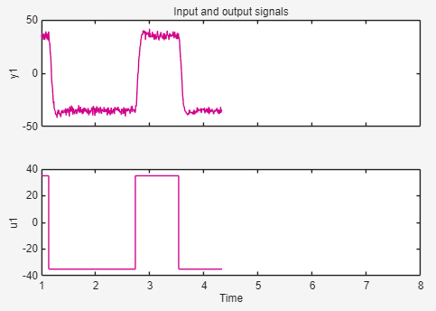

- Repeat the Steps 11 to Step 15 to identify the model. Name the model as model2. Right-click on the model2 box and find the estimated transfer function model of the DC motor system from noisy data. Provide the new model and the validation criteria below:

Estimated Transfer Function Model =
$\frac{863.8}{s^{2}\text{+}42.31s\text{+}860.4}$
Fit to estimated data = 93.77 %
FPE = 4.478
MSE = 4.433

- Select model2 and deselect model1. Check the Model output box to view the overlap of the validation data and the model resulting from the identification of noisy system. Provide the graph with the Best fit results below. Check the Zero and poles box to view the pole-zero map. Provide the graph below.
Cross-Validation Results for Noisy Dataset Pole-Zero Plot for Noisy Dataset
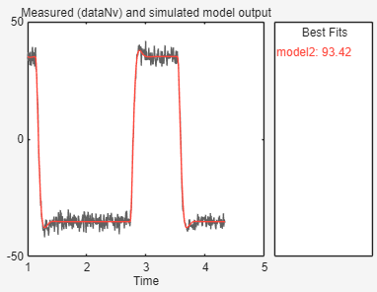 | 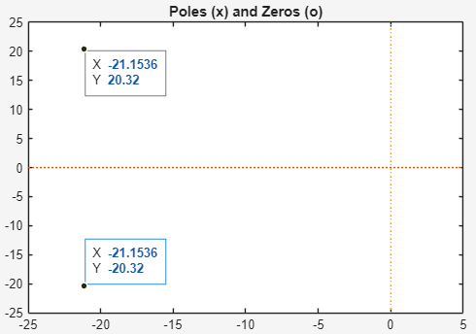

- Enter the pole and zero values below:
Poles = -21.1536 ± 20.32
Zeros = No Zeros

- Compare the validation results of noisy dataset in Step 24 with the noise-free dataset in Step 15. Explain how the additive noise effects the estimated transfer function model and the validation criteria.
Compare the poles’ location in model1 and model2 from Step 17 and Step 26. Are they almost in the same location?
Additive noise in system identification affects the predicted transfer function model's accuracy and reliability.
Noise increases variability, which can change the underlying system response and make the estimated model less accurate. In fact, this results in a transfer function that may not accurately portray the system's underlying
dynamics, particularly if the noise is significant in comparison to the signal. This issue is typically addressed with
model validation criteria such as fit percentages and error metrics, which may indicate decreasing accuracy when the model incorporates noisy input.

The poles in the two variations are near each other, but they are not identical. This slight variance might be due
to differences in how the models react to noise. Since poles represent the stability and inherent responsiveness
of the system, slight changes in pole position imply that noise has some effect on the predicted dynamics of the
system. Even little differences can have an impact on the model's predictability, even though comparable
dynamic behavior is typically inferred when poles in various models are close to one another.

- Compare the cross-validation results in Step 16 and Step 25. Which model has better percentage of fit on the validation data? Model1 or Model2? Check the cross-validation graph of noisy system. Did the identified model from noisy dataset successfully capture the dynamics of the system? If yes, discuss why the model from the noisy dataset has less percentage of fit? Provide ideas to improve the percent of fit for noisy dataset.
Compared to Model 2, Model 1 more accurately depicts the system's behavior on the validation dataset. The
model's fit is jeopardized by the noise, though, if the noisy system's cross-validation graph displays notable
deviations. A poor fit percentage might result from the model capturing both the real system dynamics and some
noise-related features in a noisy dataset.
When the data is noisy, the model tends to include components of the noise into its structure, resulting in
"over fitting" rather than accurately describing the system dynamics. This results in a model that performs well on
noisy data but poorly on unseen or less noisy data, yielding a lower fit percentage. Noisy input might obscure the
system's true links, making generalization more difficult and lowering the model's predictive ability.
Improvement for noisy data: Noise Filtering, Regularization, Data Segmentation, Increasing Model Order, Ensemble Methods.

- Drag the model2 box to To LTI Viewer box to plot the unit-step response of the system. Provide the step response graph below:
Unit-Step Response (Noisy Data) Step Response Specifications
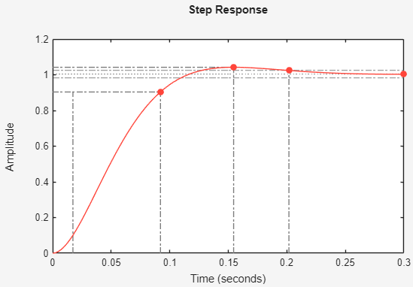 | Rise time = 0.0748 sec  Peak time = 0.155 sec  Overshoot = 3.8 %  Settling time = 0.202 sec  Steady-state value = 1  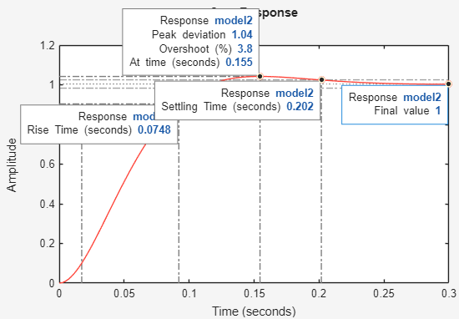

- Compare the step response specifications of the model from noisy dataset in Step 29 and the noise-free dataset in Step 18. How close the values are? What can you conclude about the accuracy of the two models?
Overall, both models are quite close, but Model 1 is marginally better in terms of stability and accuracy based on
these metrics.
Model 1 is likely a slightly more accurate representation of the system's true behavior, as it fits the validation
data better and has a bit less overshoot.
Model 2, while close in performance, may be slightly affected by the noise in the data, leading to a slightly higher overshoot and lower validation fit.

Post Lab Assignment
- Build the following system using Simscape. Set the component values as $R\text{=}1Ω, L\text{=}2H$ and $C\text{=}3F$.
Open the Model Settings window and set the Solver to ode23t.
Run the simulation for 50 seconds and provide the Scope plot.
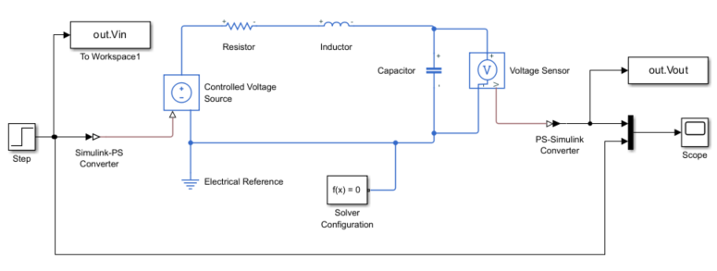
Create a Subsystem as shown below and suppose that it is an unknown system.
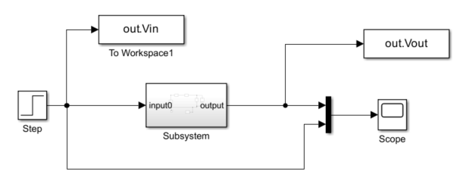
Set the sample time of the To Workspace blocks to 0.01 seconds.
First, create a step input starting from 0, with an initial value of 0 and a final value of 2.
Run the simulation and collect the input and output data. Provide the Scope plot. The input and output data will be saved in Workspace as out.Vin and out.Vout variables. Save this data as the identification data:
In_i = out.Vin;
Out_i = out.Vout;
Next, create a step input starting from 1, with an initial value of -1 and a final value of 3.
Run the simulation and collect the input and output data. Provide the Scope plot. The input and output data will be saved in Workspace as out.Vin and out.Vout variables. Save this data as the validation data:
In_v = out.Vin;
Out_v = out.Vout;
Estimate a transfer function model for this system using the System Identification Toolbox App by selecting appropriate numbers of poles and zeros.
Provide the estimated model, all validation criteria results (FPE, MSE, Fit to the estimated data), cross-validation plot and the pole-zero map. Discuss the validity of the identified model based on the results.
Provide the Simulink file, all the required graphs and the results.

a)
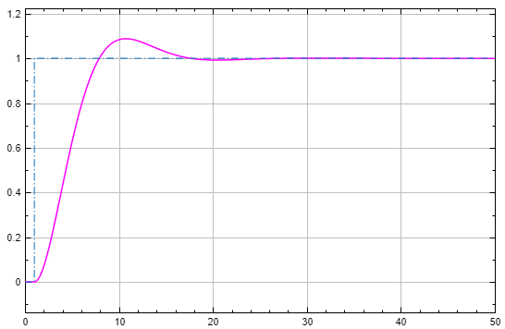
b)
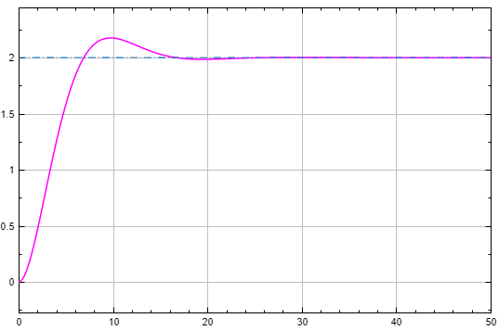
c)
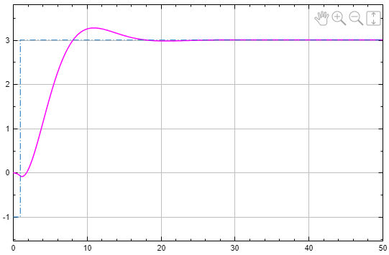
d)
Estimated Transfer Function Model =
$\frac{0.375}{s^{2}\text{+}0.75s\text{+}0.375}$
Fit to estimated data = 100 % (Stability enforced)
FPE = 4.915e-13
MSE = 4.905e-13
Poles = -0.374999 ± 0.484121
Zeros = No Zeros
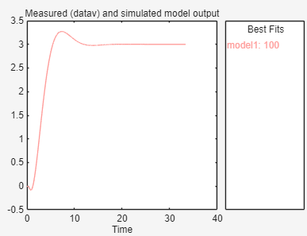
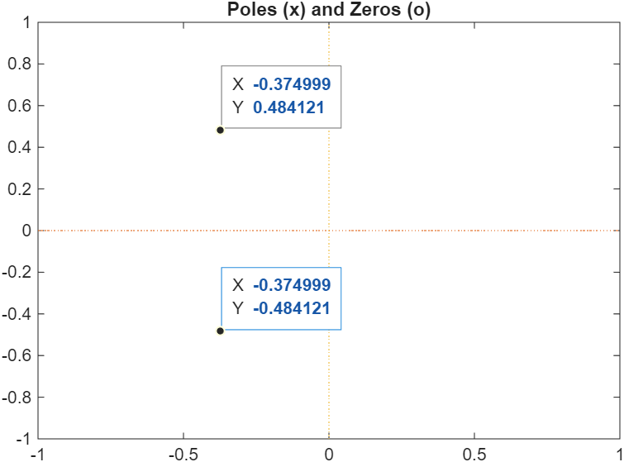

The identified transfer function model is valid, stable, and accurately reflects the system dynamics, showing excellent agreement with the measured data. As long as independent validation confirms the results, the model can confidently be used for prediction, simulation, or controller design.

